Music from Oberlin

This collection of music comes primarily from a number of CDs that Roy Christensen, retired owner of Gasparo Records, offered to Oberlin a few years ago. They were mostly masters of unreleased LPs professionally recorded in the late 1970’s. The audio that is in the IBook has been remastered using modern technology, but the audio files in this collection are at various levels of outdated sound. Some are from live performances, some are from CDs made directly from an LP, some are masters of unreleased albums made with 1970’s high level sound techniques.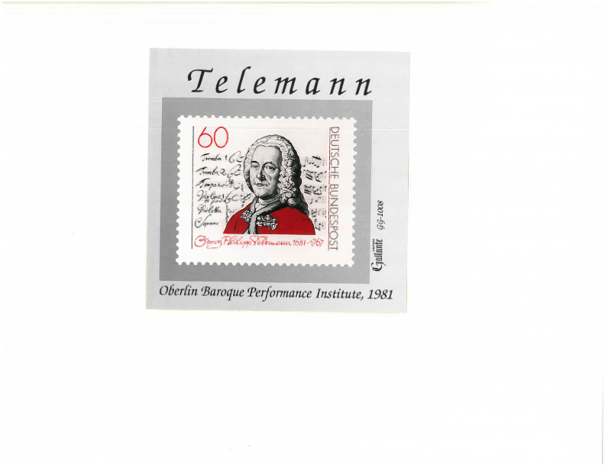

The order is by national musical styles which is a very important component of understanding baroque style. Knowing the context of musical compositions is one of the things Wenzinger and the other BPI faculty have continually stressed. Within the groups the music is somewhat chronological which is another important aspect of appreciating the varying styles. Most of the performances are related to the Oberlin Baroque Performance Institute but there are also albums from the Oberlin Consort of Viols, The Cleveland Baroque Soloists, and others related to Oberlin.

The live performances, including the very first piece played at BPI are a reminder that the music making from nearly fifty years ago is still thrilling. The unreleased albums have never been heard by anyone but the performers, and the reissues of LP’s in this new format makes music that hasn’t been easily available ready to be heard. Enjoy!

This is where you add the list unless you think it should be on a new page.